Exercise 1: Configuring a Basic Spring Application
Scenario:
Your company is developing a web application for managing a library. You need to use the Spring Framework to handle the backend operations.
Steps:
- Set Up a Spring Project:
  - Create a Maven project named LibraryManagement.
  - Add Spring Core dependencies in the pom.xml file.
- Configure the Application Context:
  - Create an XML configuration file named applicationContext.xml in the src/main/resources directory.
  - Define beans for BookService and BookRepository in the XML file.
- Define Service and Repository Classes:
  - Create a package com.library.service and add a class BookService.
  - Create a package com.library.repository and add a class BookRepository.
- Run the Application:
  - Create a main class to load the Spring context and test the configuration.

Code :
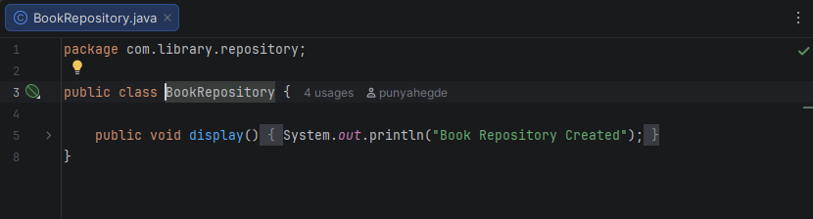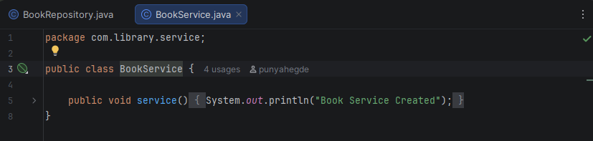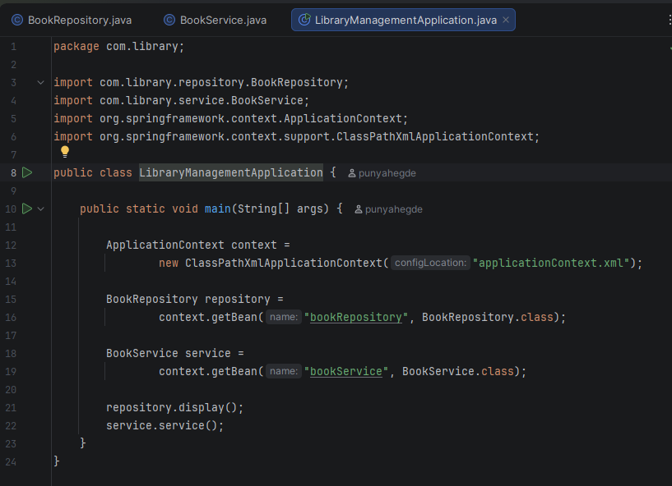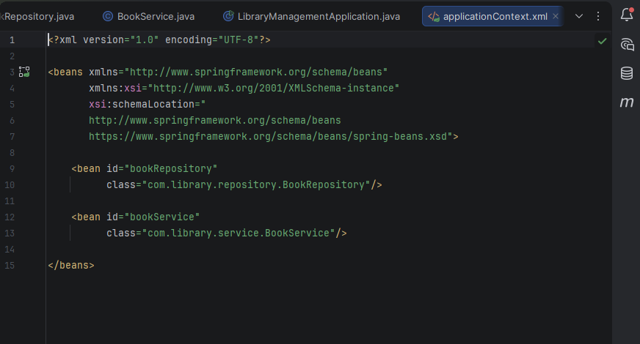

Output :
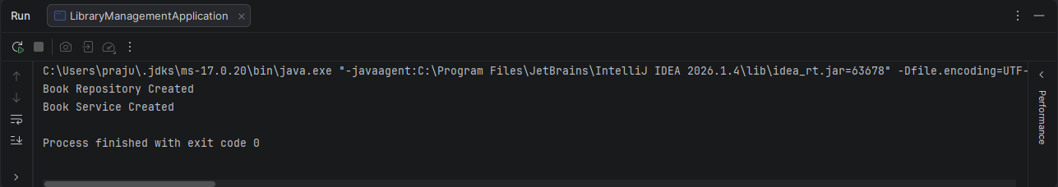

Exercise 2: Implementing Dependency Injection
Scenario:
In the library management application, you need to manage the dependencies between the BookService and BookRepository classes using Spring's IoC and DI.
Steps:
- Modify the XML Configuration:
  - Update applicationContext.xml to wire BookRepository into BookService.
- Update the BookService Class:
  - Ensure that BookService class has a setter method for BookRepository.
- Test the Configuration:
  - Run the LibraryManagementApplication main class to verify the dependency injection.

Code :
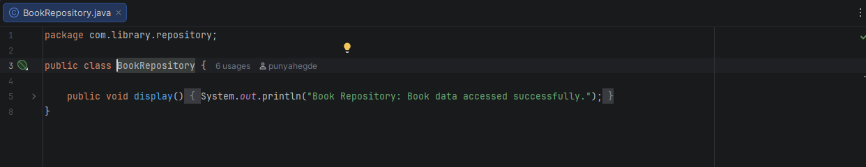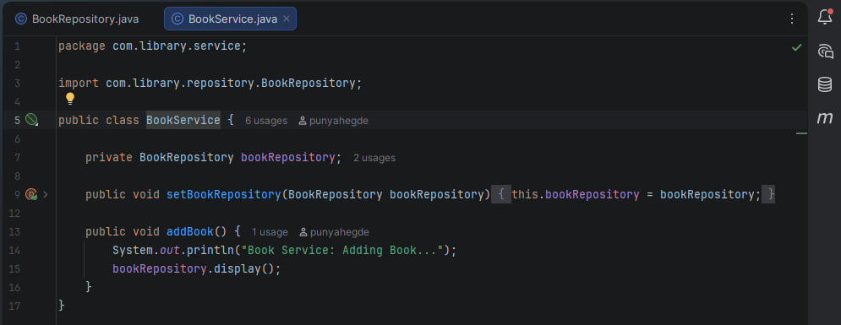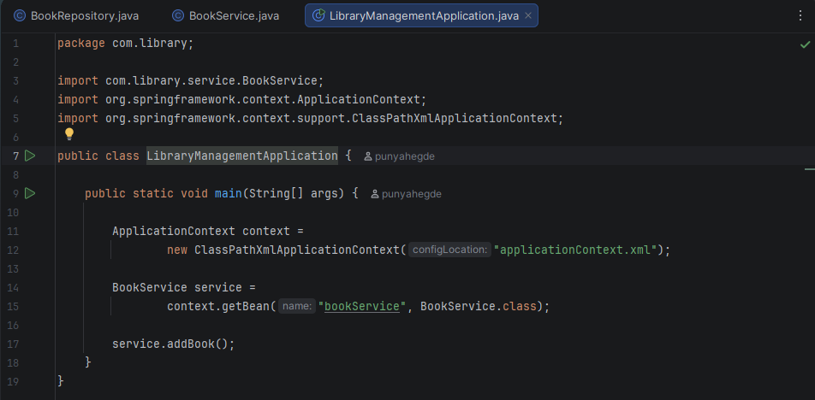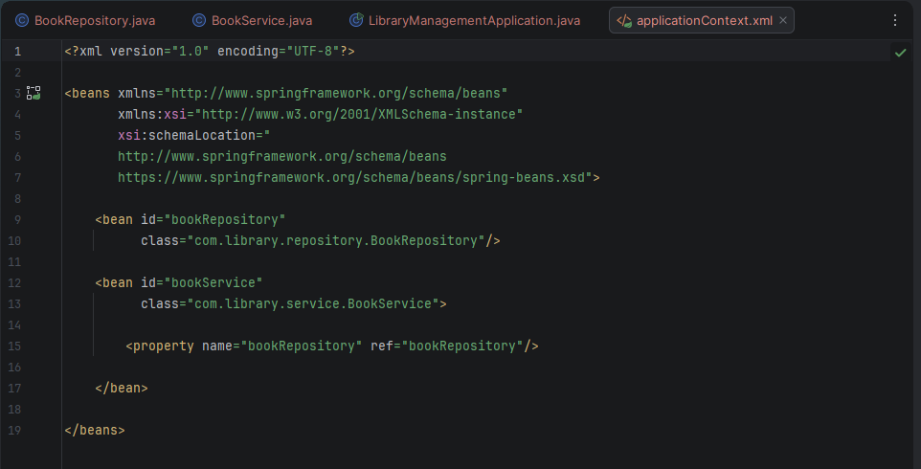

Output :
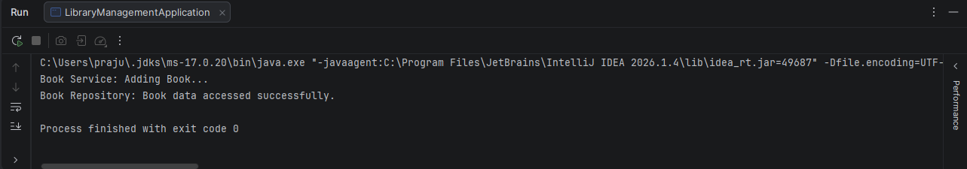

Exercise 4: Creating and Configuring a Maven Project
Scenario:
You need to set up a new Maven project for the library management application and add Spring dependencies.
Steps:
- Create a New Maven Project:
  - Create a new Maven project named LibraryManagement.
- Add Spring Dependencies in pom.xml:
  - Include dependencies for Spring Context, Spring AOP, and Spring WebMVC.
- Configure Maven Plugins:
  - Configure the Maven Compiler Plugin for Java version 1.8 in the pom.xml file.

Code :
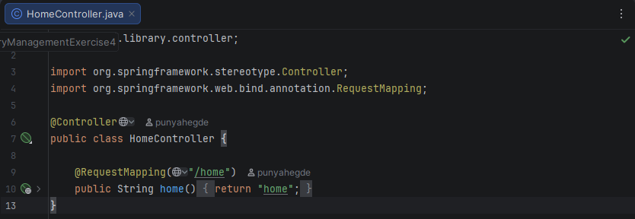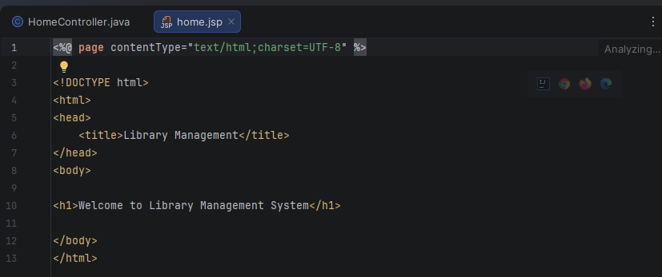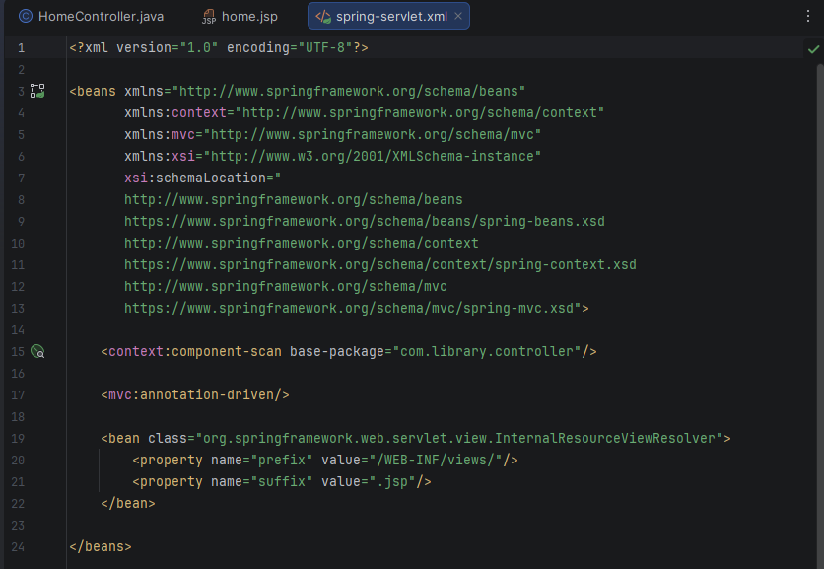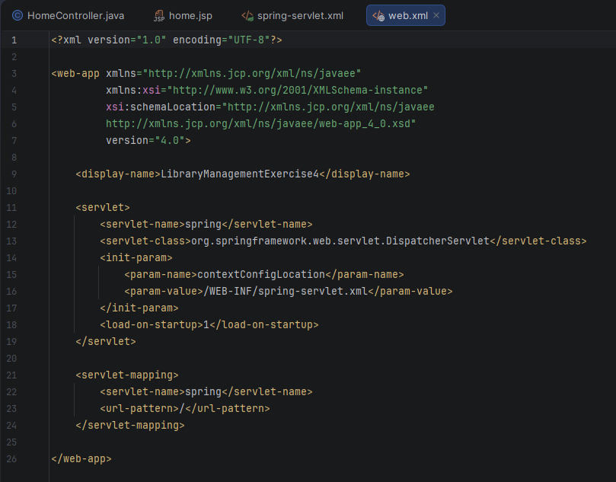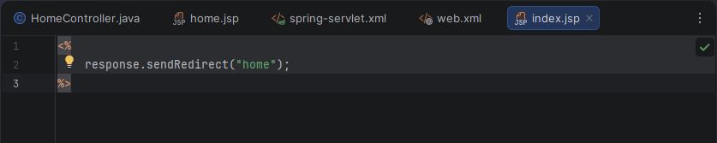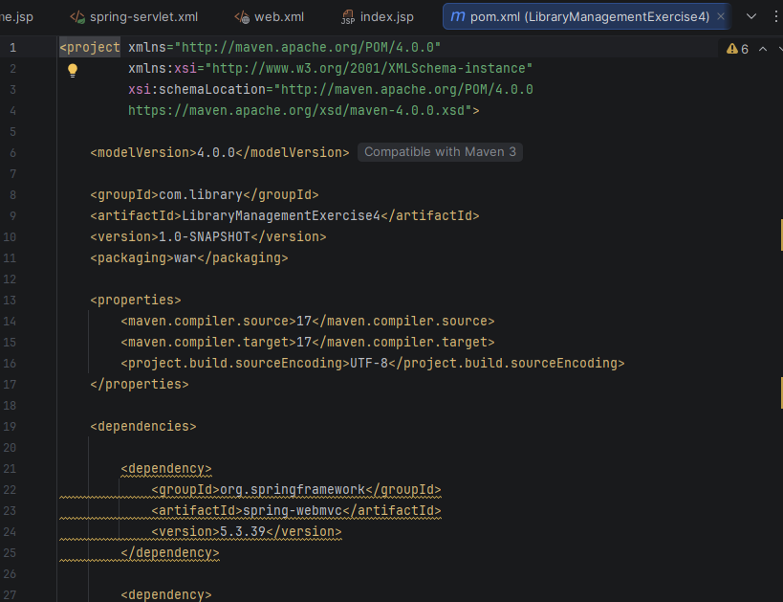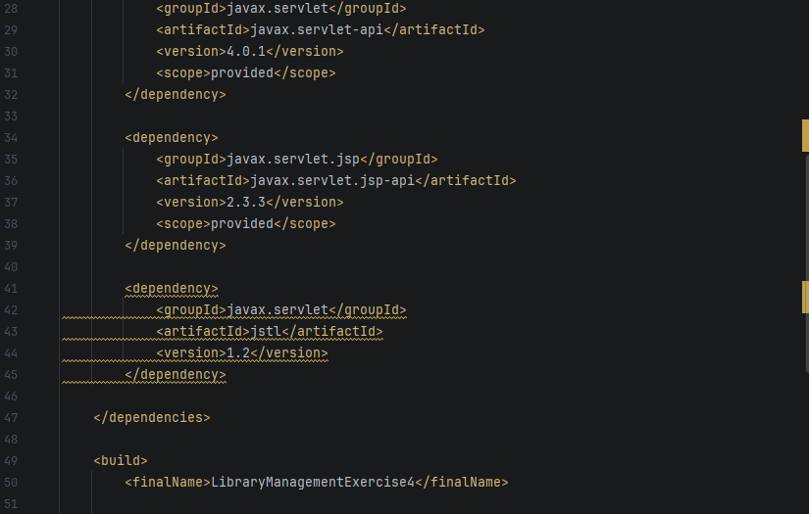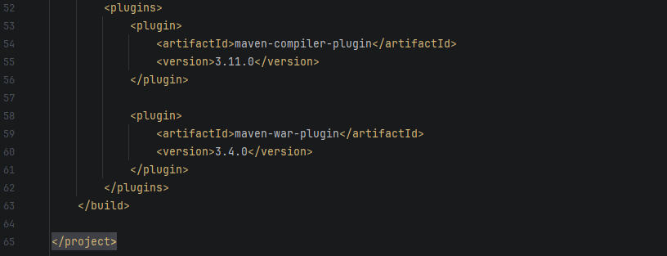
Output :
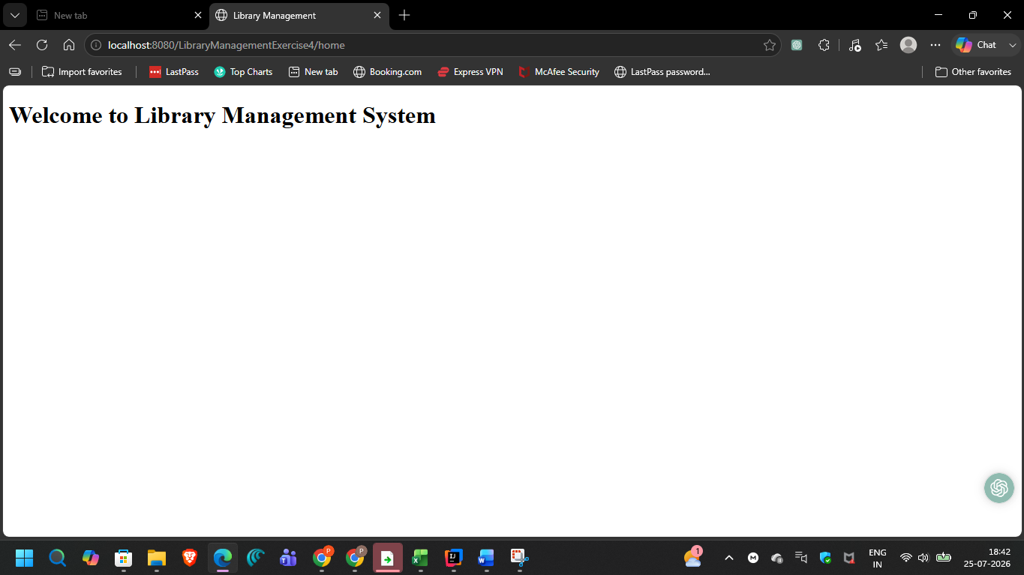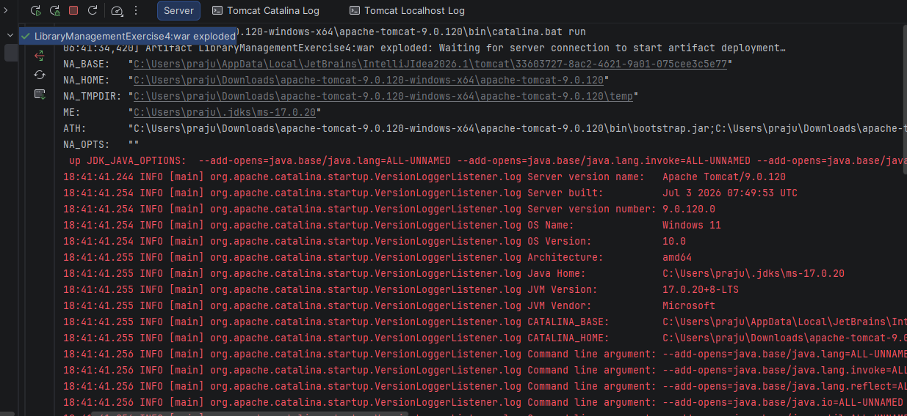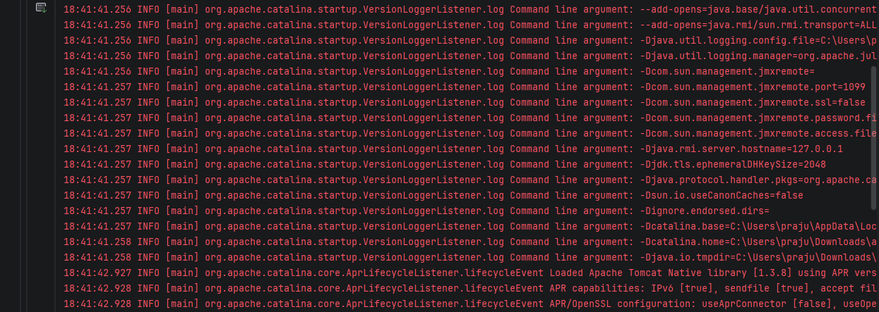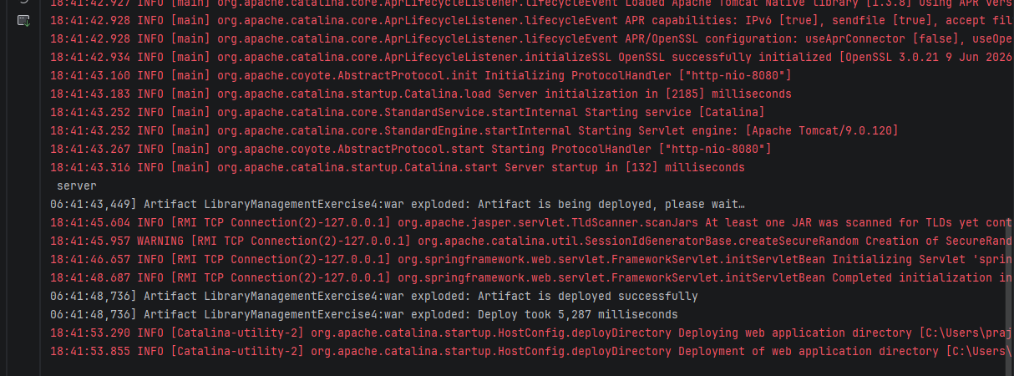

Exercise 5: Configuring the Spring IoC Container
Scenario:
The library management application requires a central configuration for beans and dependencies.
Steps:
- Create Spring Configuration File:
  - Create an XML configuration file named applicationContext.xml in the src/main/resources directory.
  - Define beans for BookService and BookRepository in the XML file.
- Update the BookService Class:
  - Ensure that the BookService class has a setter method for BookRepository.
- Run the Application:
  - Create a main class to load the Spring context and test the configuration.

Code :
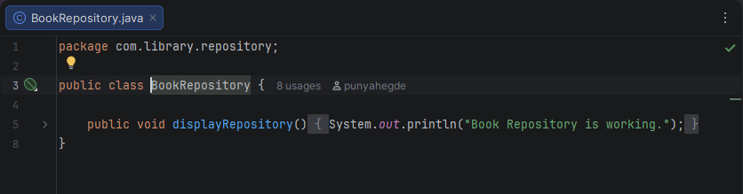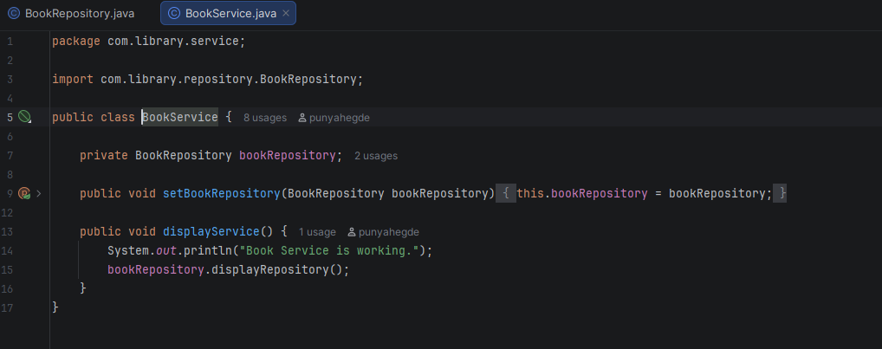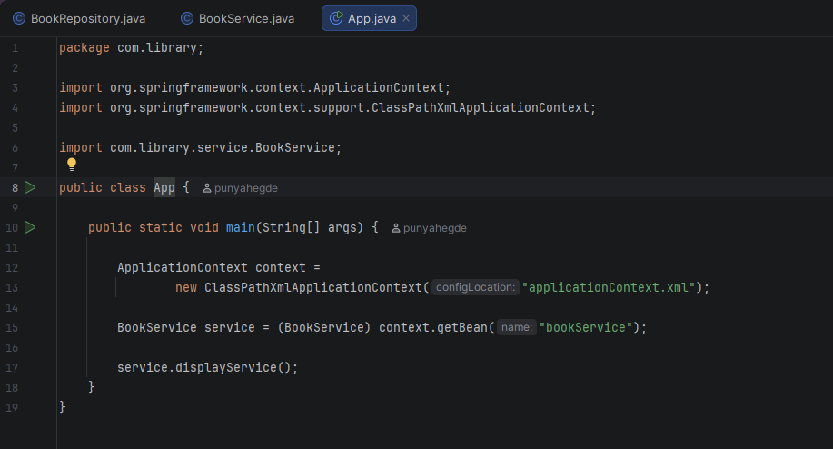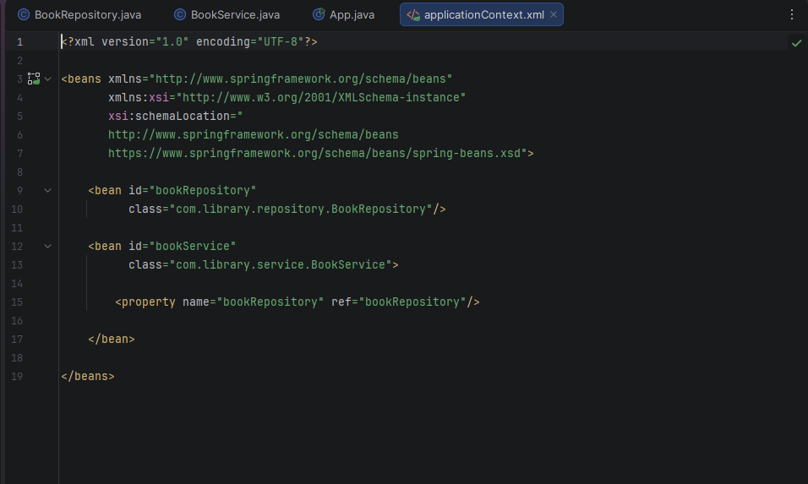

Output :
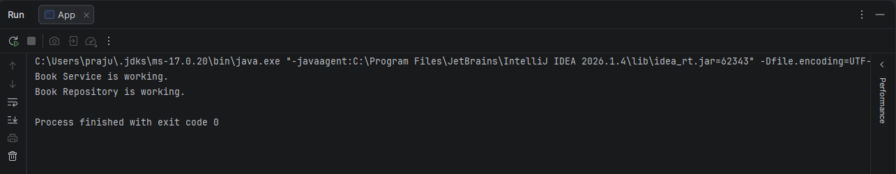

Exercise 7: Implementing Constructor and Setter Injection
Scenario:
The library management application requires both constructor and setter injection for better control over bean initialization.
Steps:
- Configure Constructor Injection:
  - Update applicationContext.xml to configure constructor injection for BookService.
- Configure Setter Injection:
  - Ensure that the BookService class has a setter method for BookRepository and configure it in applicationContext.xml.
- Test the Injection:
  - Run the LibraryManagementApplication main class to verify both constructor and setter injection.

Code :
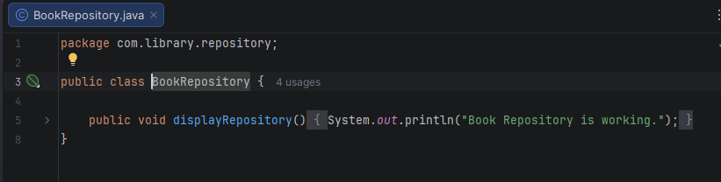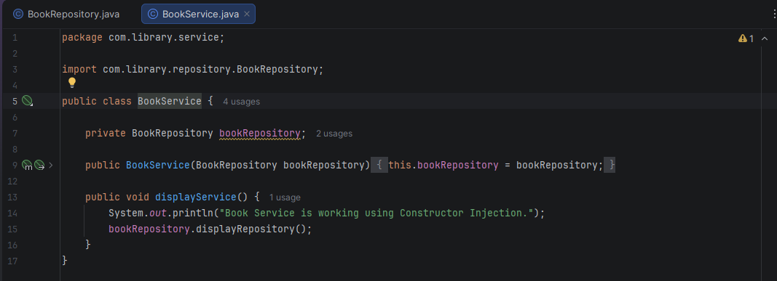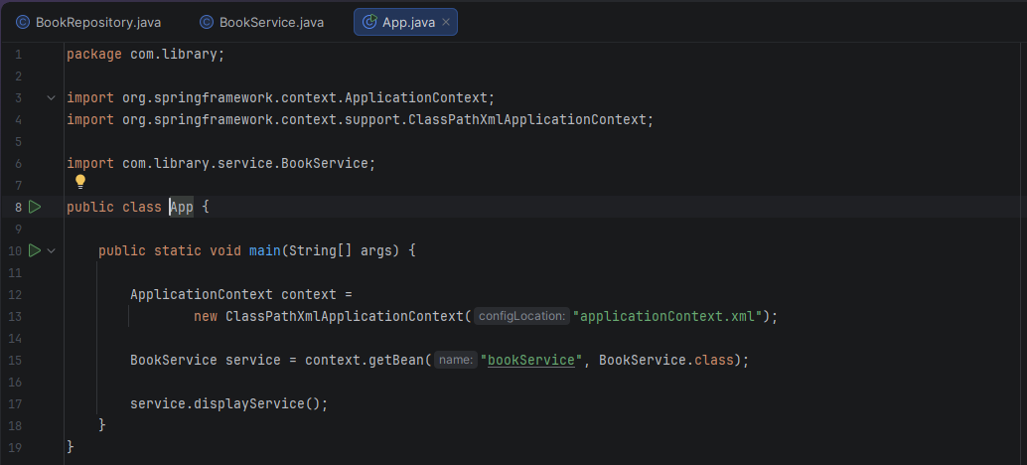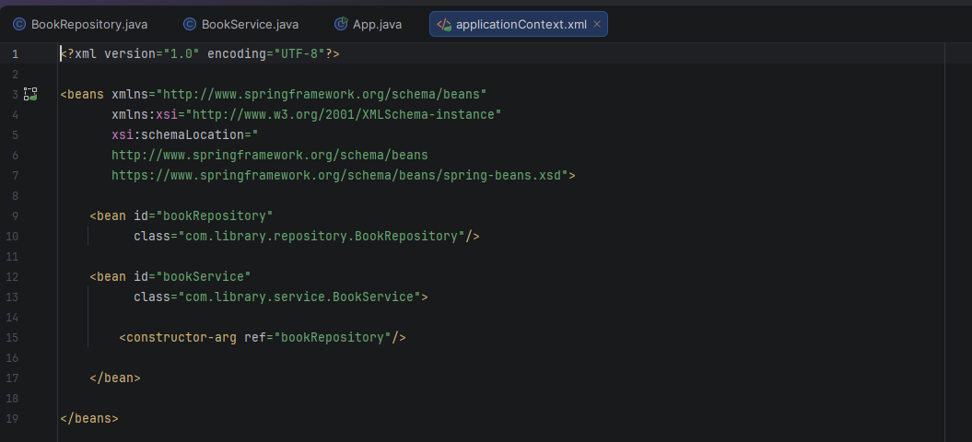

Output :
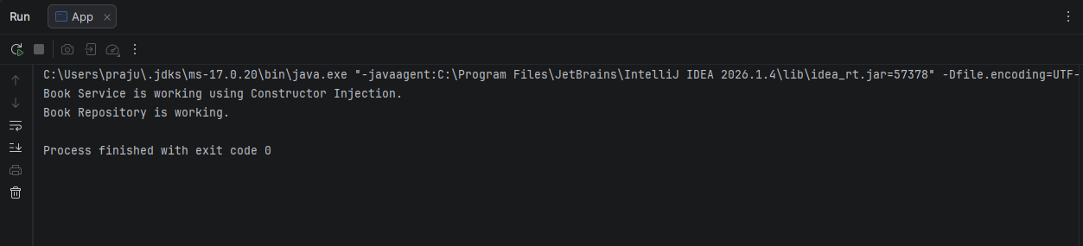

Exercise 9: Creating a Spring Boot Application
Scenario:
You need to create a Spring Boot application for the library management system to simplify configuration and deployment.
Steps:
- Create a Spring Boot Project:
  - Use Spring Initializr to create a new Spring Boot project named LibraryManagement.
- Add Dependencies:
  - Include dependencies for Spring Web, Spring Data JPA, and H2 Database.
- Create Application Properties:
  - Configure database connection properties in application.properties.
- Define Entities and Repositories:
  - Create Book entity and BookRepository interface.
- Create a REST Controller:
  - Create a BookController class to handle CRUD operations.
- Run the Application:
  - Run the Spring Boot application and test the REST endpoints.

Code :
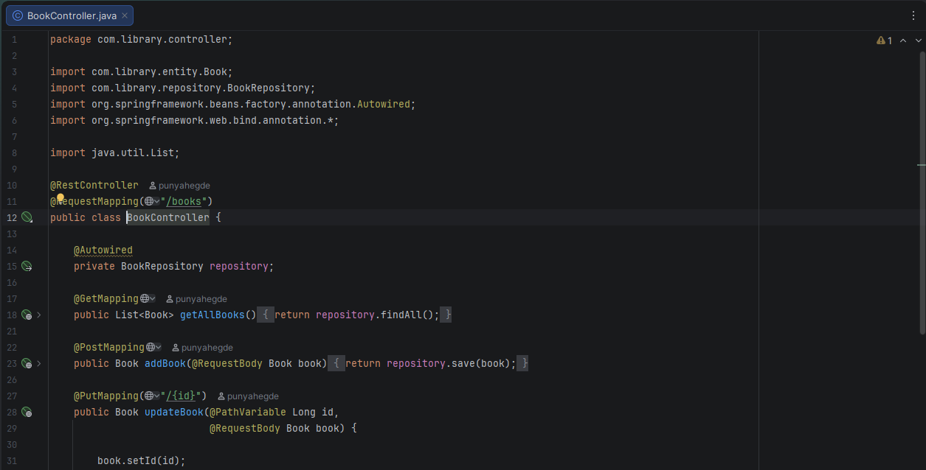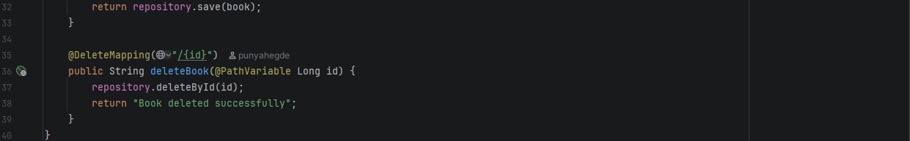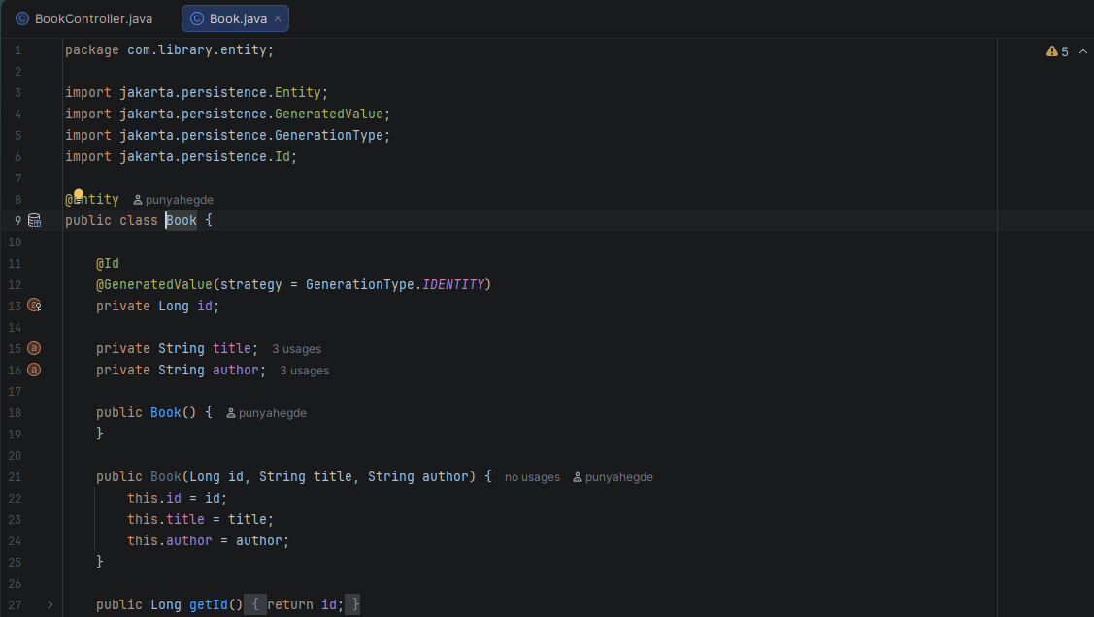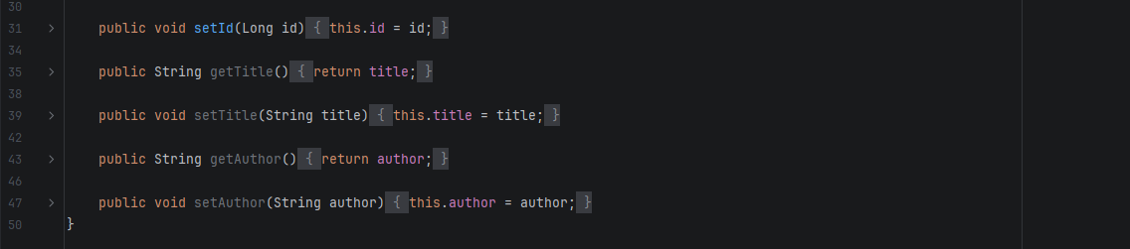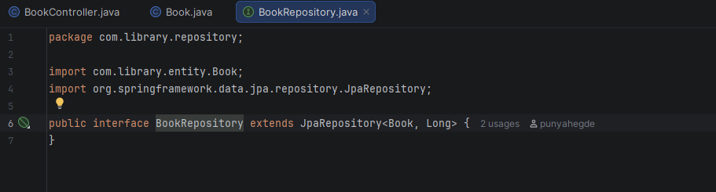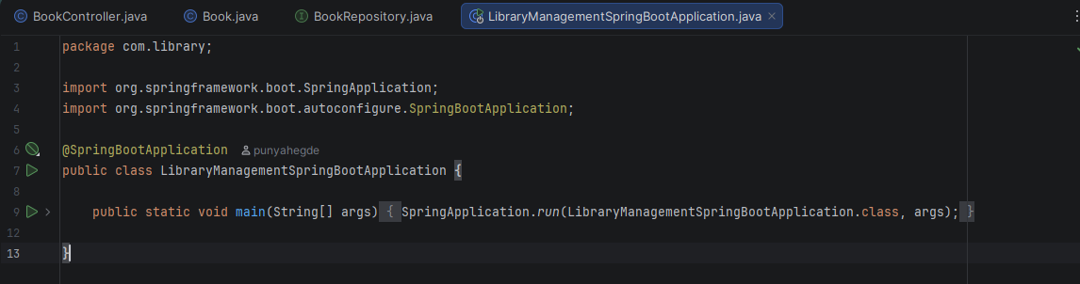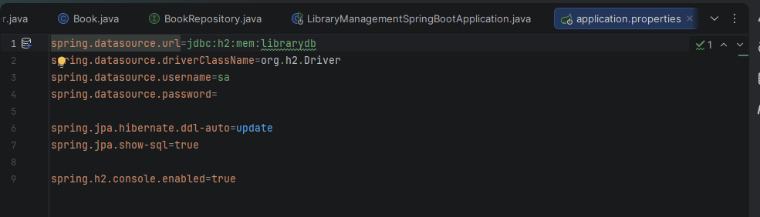

Output :
